**LAB 9**

1. CopyFile
2. package com.company;  
     
   import java.io.*;  
   public class copyfile {  
     
    public static void main(String args[]) throws IOException {  
    FileReader in = null;  
    FileWriter out = null;  
     
    try {  
    in = new FileReader("input.txt");  
    out = new FileWriter("output.txt");  
     
    int c;  
    while ((c = in.read()) != -1) {  
    out.write(c);  
    }  
    }finally {  
    if (in != null) {  
    in.close();  
    }  
    if (out != null) {  
    out.close();  
    }  
    }  
    }  
   }

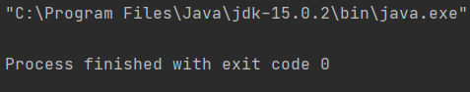

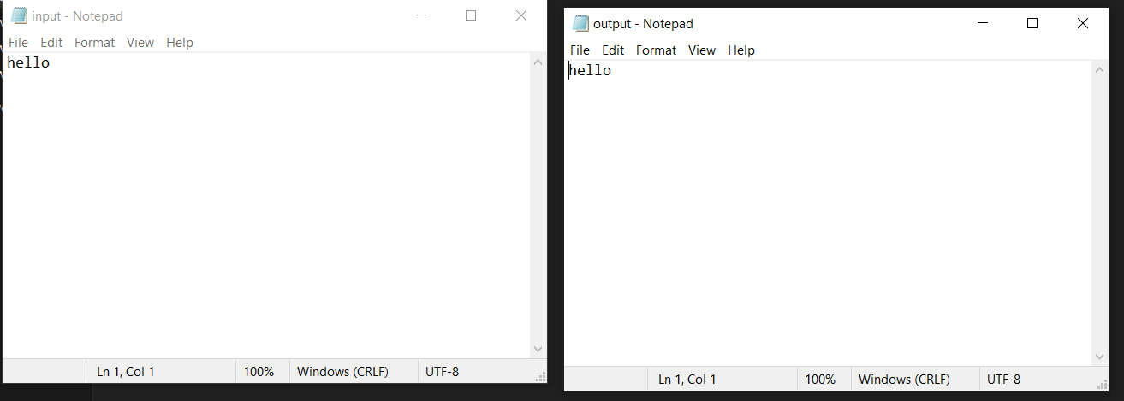

1. ReadC
2. package com.company;  
   import java.io.*;  
   public class readc {  
     
    public static void main(String args[]) throws IOException {  
    InputStreamReader cin = null;  
     
    try {  
    cin = new InputStreamReader(System.*in*);  
    System.*out*.println("Enter characters, 'q' to quit.");  
    char c;  
    do {  
    c = (char) cin.read();  
    System.*out*.print(c);  
    } while(c != 'q');  
    }finally {  
    if (cin != null) {  
    cin.close();  
    }  
    }  
    }  
   }

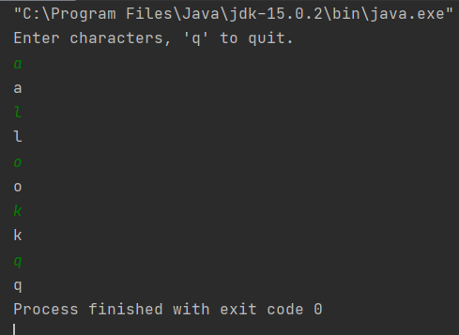

3.bin

package com.company;  
import java.io.*;  
public class bin{  
 public static void main(String args[]){  
 try{  
 byte bWrite [] = {11,21,3,40,5};  
 OutputStream os = new FileOutputStream("test.txt");  
 for(int x=0; x < bWrite.length ; x++){  
 os.write( bWrite[x] ); // writes the bytes  
 }  
 os.close();  
 InputStream is = new FileInputStream("test.txt");  
 int size = is.available();  
 for(int i=0; i< size; i++){  
 System.*out*.print((char)is.read() + " ");  
 }  
 is.close();  
 }catch(IOException e){  
 System.*out*.print("Exception");  
 }  
 }  
}

